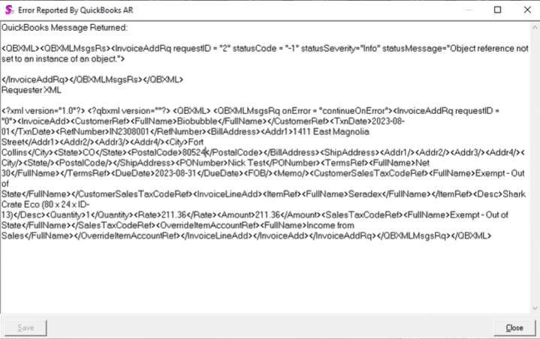QuickBooks Message Returned:

<QBXML><QBXMLMsgsRs><InvoiceAddRq requestID = "2" statusCode = "-1" statusSeverity="Info" statusMessage="Object reference not set to an instance of an object.">

</InvoiceAddRq></QBXMLMsgsRs></QBXML>
Requester XML

<?xml version="1.0"?> <?qbxml version=""?> <QBXML> <QBXMLMsgsRq onError = "continueOnError"> <InvoiceAddRq requestID = "0"><InvoiceAdd><CustomerRef><FullName>Biobubble</FullName></CustomerRef><TxnDate>2023-08-01</TxnDate><RefNumber>IN2308001</RefNumber><BillAddress><Addr1>1411 East Magnolia Street</Addr1><Addr2/><Addr3/><Addr4/><City>Fort Collins</City><State>CO</State><PostalCode>80524</PostalCode></BillAddress><ShipAddress><Addr1/><Addr2/><Addr3/><Addr4/><City/><State/><PostalCode/></ShipAddress><PONumber>Nick Test</PONumber><TermsRef><FullName>Net 30</FullName></TermsRef><DueDate>2023-08-31</DueDate><FOB/><Memo/><CustomerSalesTaxCodeRef><FullName>Exempt - Out of State</FullName></CustomerSalesTaxCodeRef><InvoiceLineAdd><ItemRef><FullName>Seradex</FullName></ItemRef><Desc>SharkCrate Eco (80 x 24 x ID-13)</Desc><Quantity>1</Quantity><Rate>211.36</Rate><Amount>211.36</Amount><SalesTaxCodeRef><FullName>Exempt - Out of State</FullName></SalesTaxCodeRef><OverrideItemAccountRef><FullName>Income from Sales</FullName></OverrideItemAccountRef></InvoiceLineAdd></InvoiceAdd></InvoiceAddRq></QBXMLMsgsRq></QBXML>

